**Active and Passive Filters**

Table of Contents

Low and High Pass Filters 3

Low and High Pass Active Filters 5

Band Pass Filters 7

A filter is a device that filters out signals based on the frequency of the signal. It is a frequency-selective circuit. It passes some signals and rejects others.

A passive filter is a filter that uses passive components, such as capacitors, resistors and inductors. This is opposed to an active filer, that uses active components such as RC networks and op-amps. This also means that passive filters do not have any amplification properties, while active filters do.

There are four basic types of passive filters:

* Low-Pass Filter: Allows frequencies below a critical frequency (cut off frequency) to pass.
* High-Pass Filter: Allows frequencies above the cut off frequency to pass.
* Band Pass Filter: Allows frequencies in a narrow range between the lower and upper cut off frequencies.
* Band Reject Filter: Rejects frequencies in a narrow range between the lower and upper cut off frequencies.

## Low and High Pass Filters



An RC Low-Pass Filter guides high frequency signals to a different path, since the impedance of a capacitor is low for high frequencies (). An RL Low-Pass Filter blocks high frequency signals, since the impedance of an inductor increases with frequency (). If we wanted to construct a High-Pass Filter, we would simply flip the positions of the resistors and capacitors/inductors.

For an RC Low-Pass Filter, you would expect all frequencies above the threshold frequency to be cut off, but in reality, it takes a little time to stop. Thus, the frequency response graph looks like this:

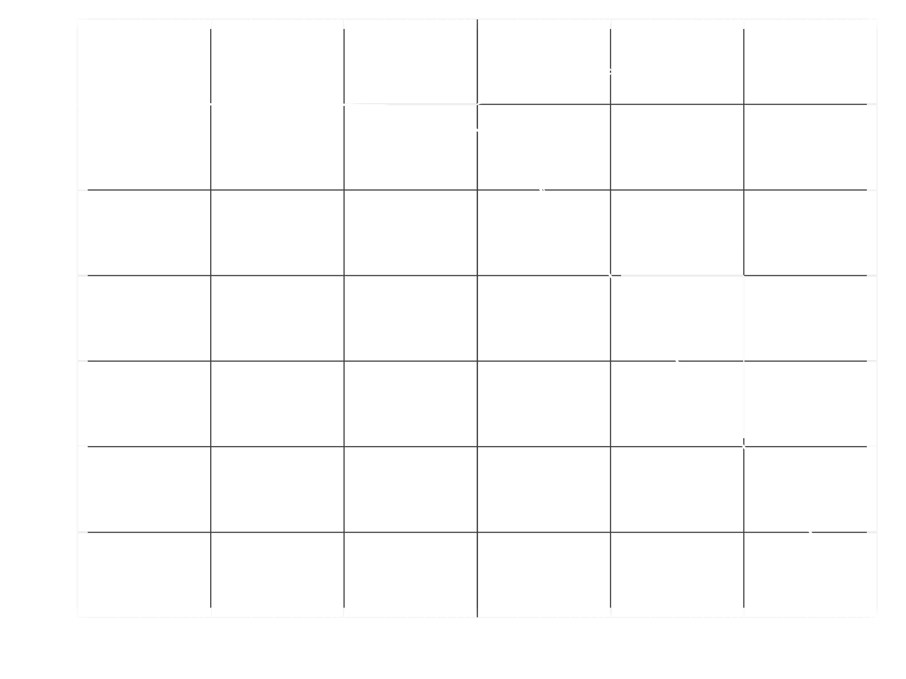

The slope depends on the value. The threshold frequency is the frequency at which the capacitive reactance and resistance are equal, i.e. .

Similarly, for a High-Pass Filter, practically the frequency response graph will look like this:



## Low and High Pass Active Filters

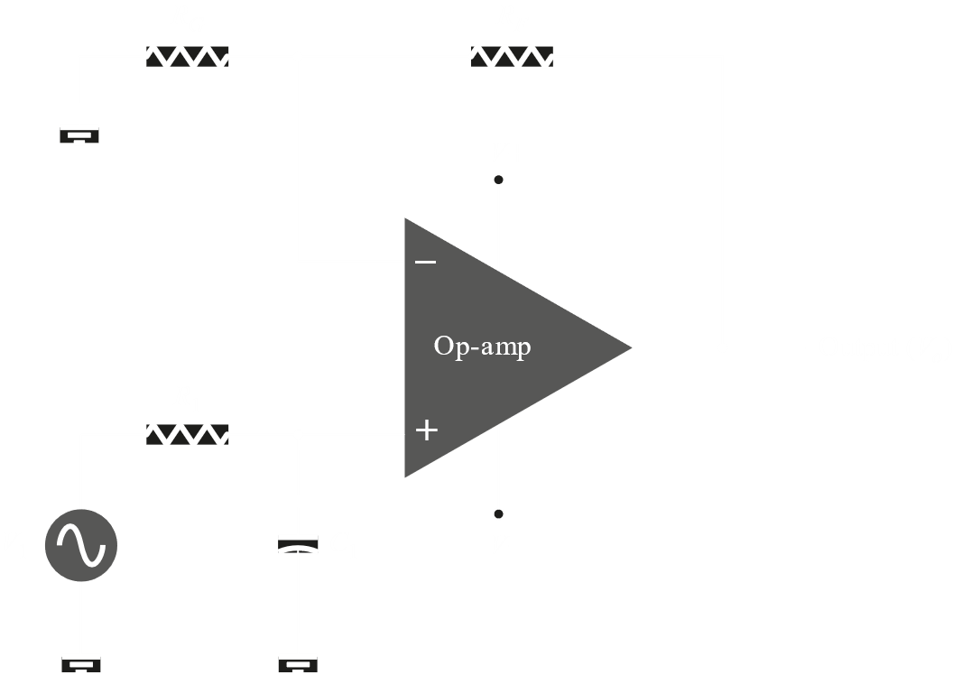 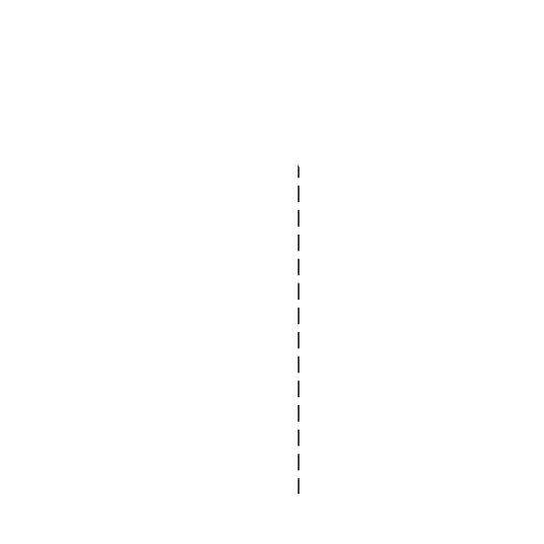

In a Low-Pass Active Filter, we attach a Low-Pass Filter circuit to the non-inverting end of an op-amp. This results in the same output as just the Low-Pass Filter, but amplified.

The circuit above uses one pair of resistor and capacitor. This is called a first order circuit. It is possible to have higher orders by adding more layers, like in the second order circuit below.

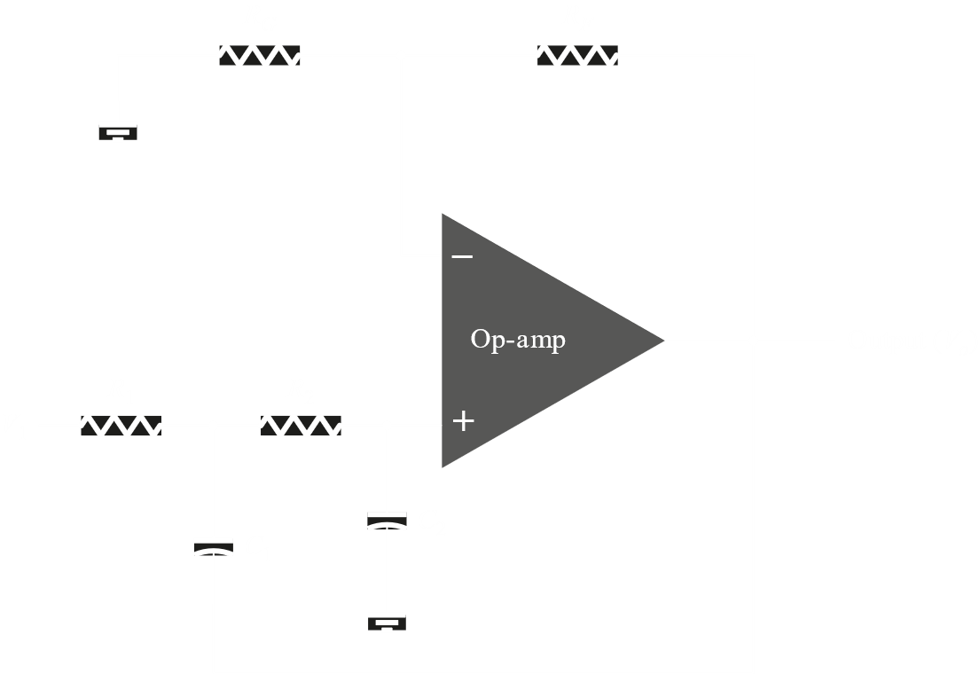 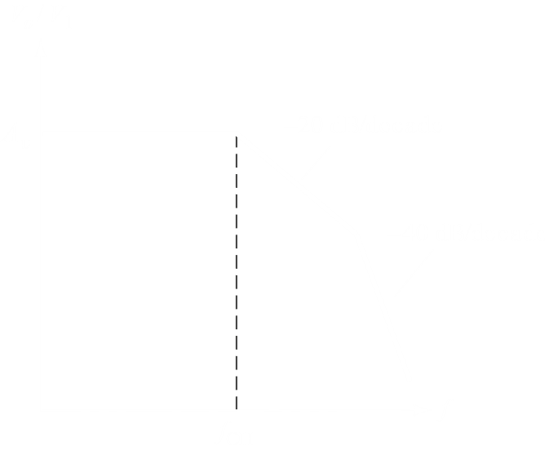

The circuits for High-Pass Filters are similar:

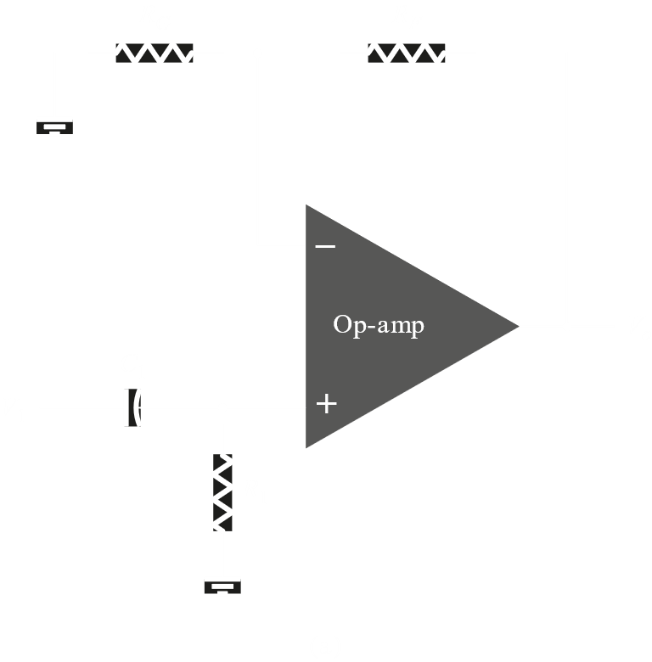 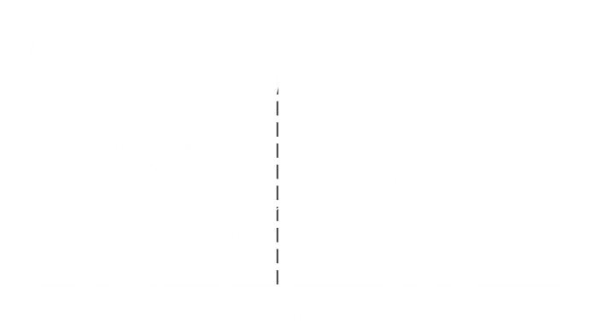

## Band Pass Filters

Band Pass Filters use a combination of a High Pass Filter and a Low Pass Filter to filter out two parts of the signals.

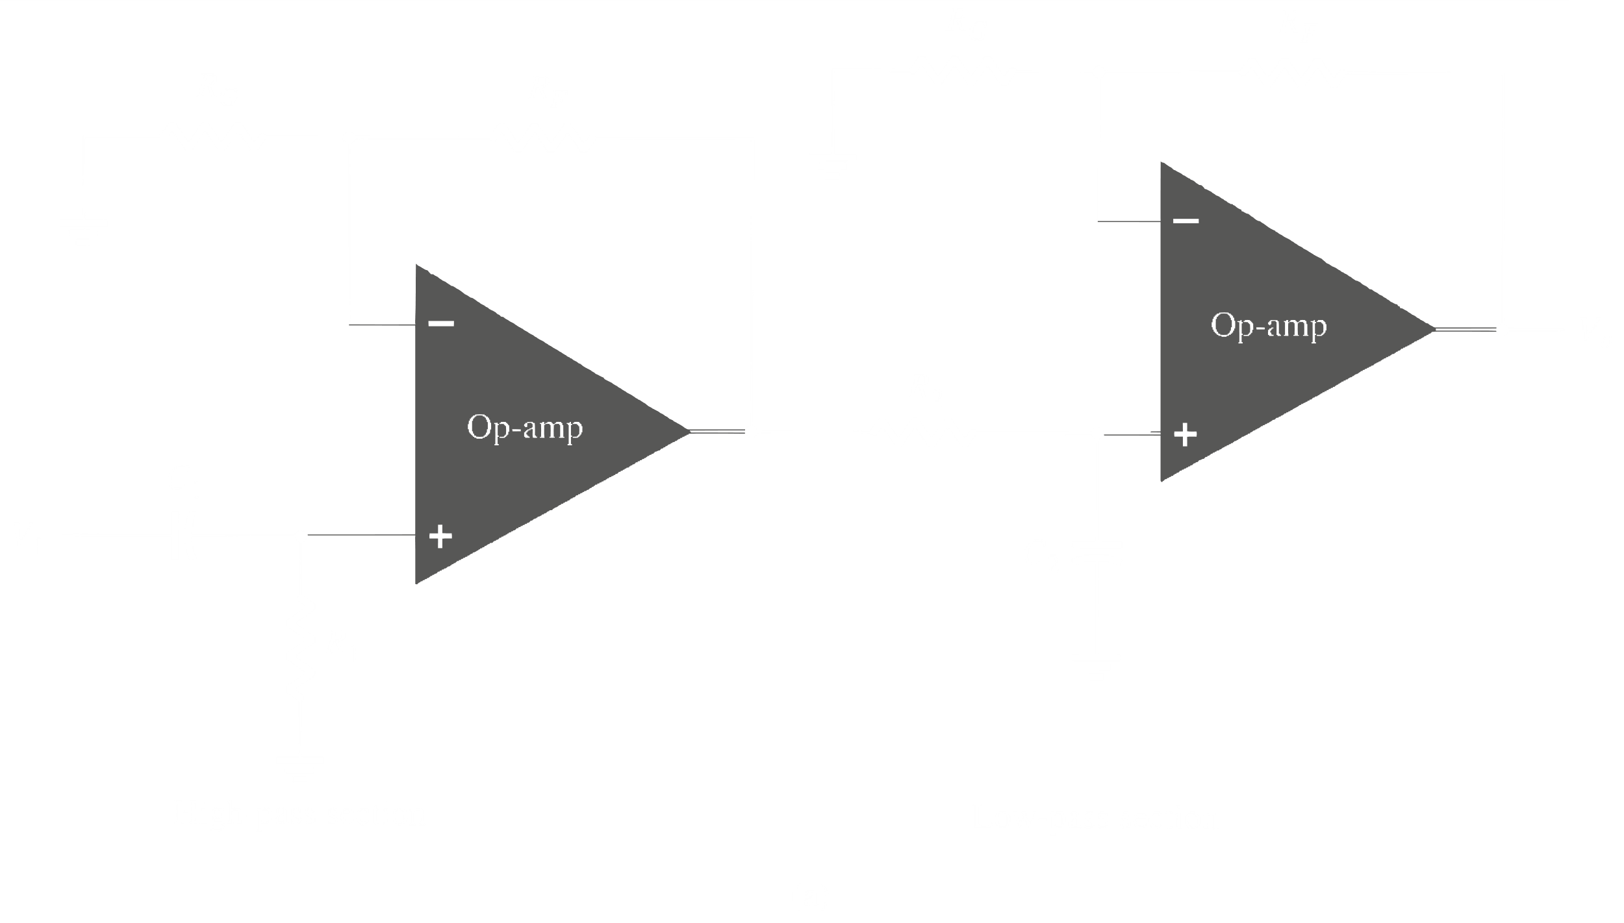 

The first high pass section allows signals with a frequency higher than the first threshold to pass. The second low pass section allows frequencies below the second threshold to pass.